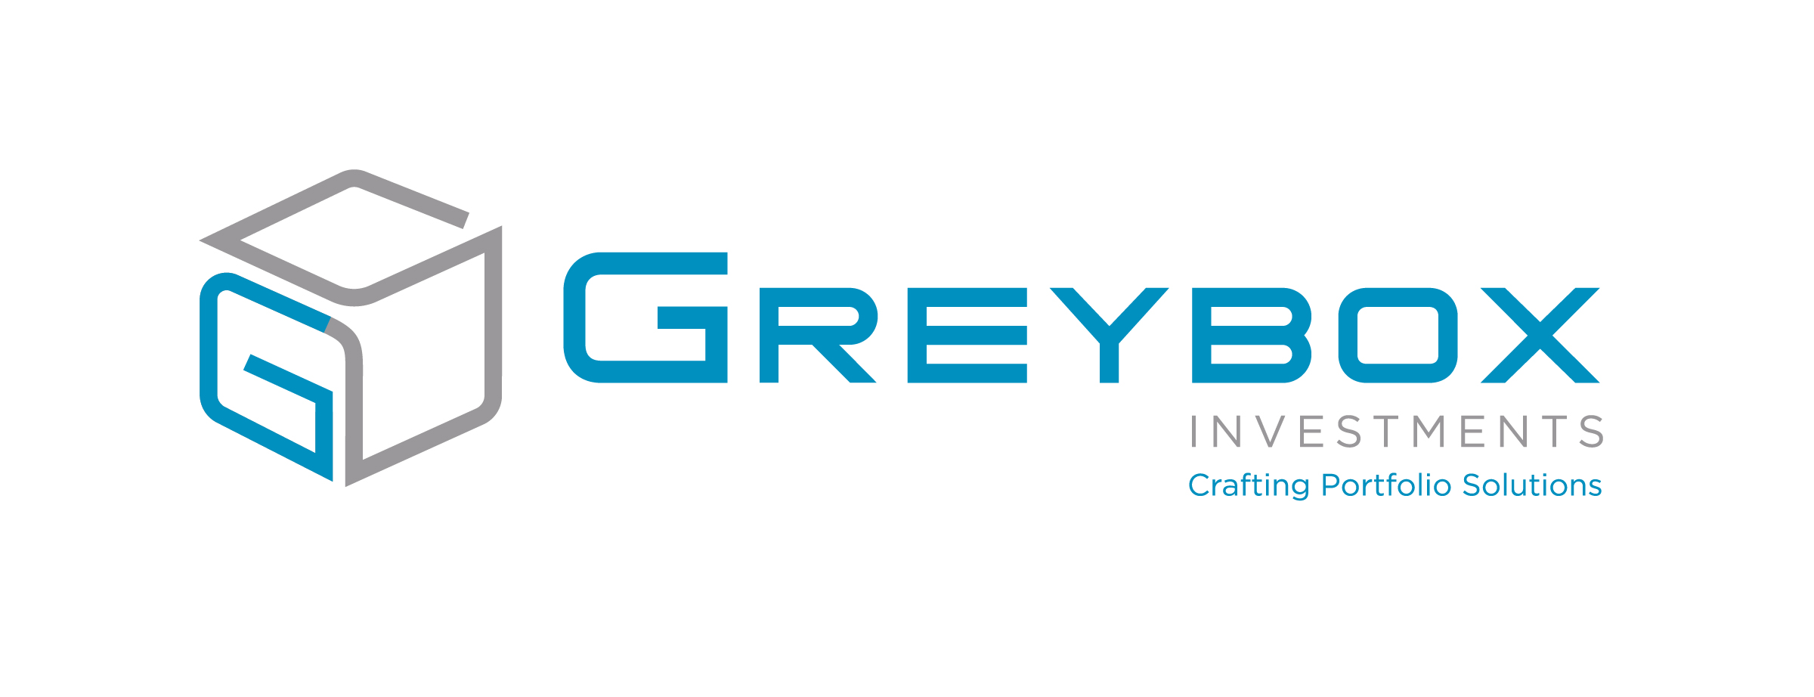
Administrative Assistant
Greybox Investments is a full service Registered Investment Advisory Office, managing over $120M in client assets. Greybox has experienced continuous growth since its inception in 2015. We attribute our sustained growth to the daily contributions of the remarkable individuals who make up our team.
We are currently searching for a Savvy Administrative Assistant to work onsite in our Birmingham headquarters. Successful candidates will have excellent customer service and must be outcome-oriented. The ability to work in a fast paced environment with strong attention to detail is essential. You will be fully engaged and busy from the first day and we guarantee there will never be a dull moment.
Responsibilities & Requirements
• Ability to juggle multiple projects with superb accuracy
• Strong administrative skills
• Exceptional customer service skills, over the phone and in person, with our customers and internal departments
• Strong sense of urgency and problem solving skills
Qualifications
• Currently possess or willing to pass FINRA Series 66 Exam
• Must be computer savvy and proficient in Microsoft Excel and Outlook
• Excellent written and verbal communication skills
Salary depends on skills and experience. Family-owned and family-friendly medical coverage, flexible benefits, employee discount and casual dress. To apply, please email Rweiss@greyboxinvestments.com To learn more about Greybox, visit www.greyboxinvestments.com

